

MIS 376 Knowledge Mapping and Data Visualization

Data Visualization Project

Project Theme: COVID-19 (or the virus, SARS-CoV-2)

Instructor : Assoc. Prof. H. Kemal ILTER, Ph.D.

Student : Ayten Tonbul

Number: 17030411012

HOW THE PANDEMIC CHANGED OUR UNDERSTANDING OF ENTERTAINMENT :

A LOOK AT THE SITUATION THROUGH TWITCH STATISTICS

In this period, the impact of the COVID-19 virus, which affects today's geography incredibly, on human behavior is unfortunately enormous.In order to observe what effect this social problem can have on human behavior, I will observe the twitch.tv data flow, which is a platform I have been in and had the opportunity to work on this platform recently, to see how often people take part in this platform to have fun ,chat etc. During Covid-19, people who were in the process of closing most of the time, met their search for music, painting-art and similar entertainment with live broadcasts. The most prominent broadcast network in this industry has been twitch.

Musicians and artists had the opportunity to meet live with people from many countries and it was very possible to see concerts, live concerts and visual feasts on this platform. People with no chance to go out have found a space for themselves to enjoy.We can clearly see the change in people's understanding of entertainment by the scope of the twitch.tv In order to do this, I will narrow my observation area and examine the viewers of years and the sections that twitch has categorized and the broadcasters that have the majority of the audience. The reasons behind my desire to move in this direction are the large number of users, having a lot of data flow, being observable, appealing to the masses, the recent involvement of politicians and seeing this as a power for them, being able to follow increases or decreases and visually to be interpreted.

Here is some news about this issue ;

CNNTURK has included a news on this subject in technology news: “ If what you watch during the pandemic period mostly includes Twitch broadcasts, you are not alone. Streamlabs and Stream Hatchet have determined that Twitch views have more than doubled in a year, from 'only' 3.1 billion hours in the first quarter of 2020 to 6.3 billion in the same quarter in 2021 ... Twitch has already dominated live streaming, and it became even more important as musicians and other non-game creators flocked to the platform to replace face-to-face concerts and discussions. Even game-oriented publishers have more reasons to use Just Chatting. If they can't socialize face-to-face, they can also make money from virtual chats. Covid-19 seems to have worked for platforms in this respect. “ Beside to the Turkish media, the situation was also covered in the foreign press ;

“ The COVID-19 pandemic that spread across the world at the beginning of 2020 was not only a big threat to public health, but also to the entire entertainment industry. While cinemas and theaters closed their doors to try to stem the spread of the disease, many people turned to home entertainment and eSports during periods of self-isolation. In March 2020, the online eSports streaming service Twitch set an all-time record of 22.7 million peak daily active users. “

*(*Clement, J., *COVID-19: Twitch user increase 2020 ,* Jan 29, 2021*)*

“…According to the streaming software company StreamElements — which conducts regular surveys of the streaming landscape with its analytics partner Arsenal.gg — viewership on Twitch is up. By a lot. Over the last week, it’s increased by a full 10 percent. As StreamElements CEO Doron Nir wrote in an email, that reflects “the popularity of the livestreaming medium now that people are consuming higher volumes of entertainment at home.” Translation: because we all have to stay inside now to flatten the coronavirus’s infection curve, everyone is watching stream..“

*(*Stephen, B*. ,TheVERGE ,This is Twitch’s moment ,* Mar 18, 2020*)*

“…With the sudden influx of variety content on a previously game-dominated platform, Twitch recorded seventeen billion hours of views in 2020, which was an 83 percent increase compared to nine billion hours in 2019. “Just Chatting” emerged as the number one category, with major titles like League of Legends and Fortnite moving down the ladder. COVID-19 has created an interesting opportunity for streamers to capitalize on and I am genuinely looking forward to seeing how the live streaming industry develops and what new formats emerge in 2021, especially since it seems like we’ve still got a long way to go…“

*(*Kim , S. *, Twıtch: The Ultımate covıd-19 Benefıcıary ,*Mcgıll's student-run news magazine, Jan 25, 2021*)*

As seen in the news, Twitch became one of the sites that saw and used the opportunities brought by the pandemic process. The fact that this website was able to meet people's entertainment needs during this period gave it the opportunity to grow at an incredible rate. Now we will examine this data over data visuals.

Datas and Data Visuals:

|  |  |  |
| --- | --- | --- |
| YEAR | AVERAGE VIEWERS | MAX VIEWERS |
| January 2013 | 147,967 | 466,539 |
| January 2014 | 290,265 | 744,353 |
| January 2015 | 498,183 | 1,161,719 |
| January 2016 | 645,791 | 1,260,081 |
| January 2017 | 811,303 | 2,214,408 |
| January 2018 | 967,916 | 2,311,939 |
| January 2019 | 1,275,970 | 2,348,770 |
| January 2020 | 1,357,375 | 2,422,452 |
| January 2021 | 2,919,533 | 6,577,002 |

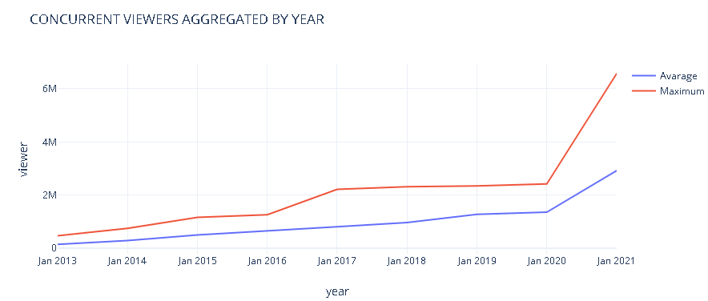

During the pandemic, the average viewership has nearly doubled and the maximum number of viewers has exceeded 6 million.

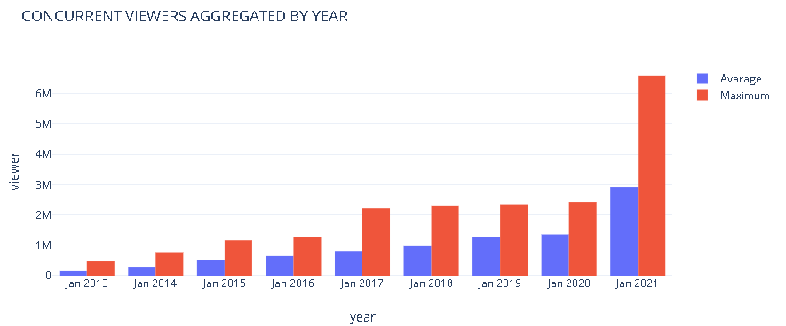

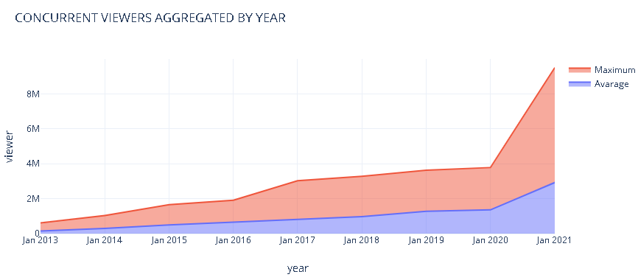

|  |  |
| --- | --- |
| YEAR | HOURS WATCHED |
| January 2013 | 110,087,448 |
| January 2014 | 215,715,273 |
| January 2015 | 370,468,152 |
| January 2016 | 480,468,504 |
| January 2017 | 603,609,432 |
| January 2018 | 720,129,504 |
| January 2019 | 949,321,680 |
| January 2020 | 1,009,887,000 |
| January 2021 | 2,171,159,374 |

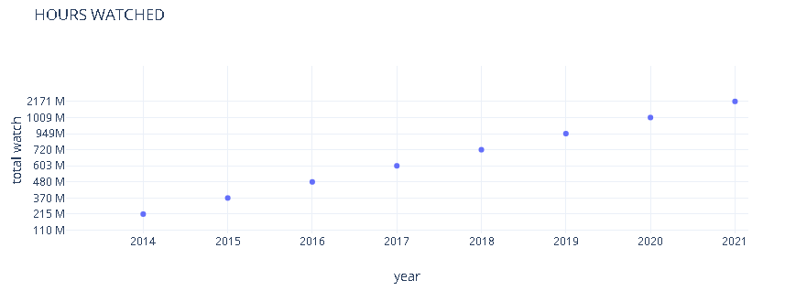

The viewership distribution of some of the most followed Twitch Channels is shown below with a circular area chart. Ninja has the highest number of views among all channels ;

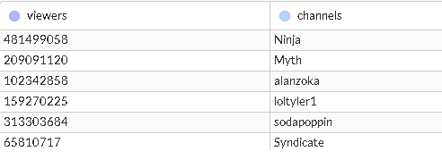

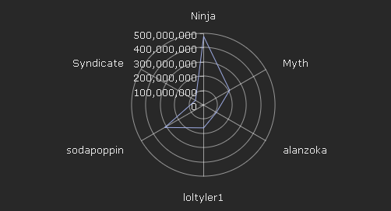

|  |  |
| --- | --- |
| YEAR | BROADCASTERS |
| January 2013 | 300 K |
| January 2014 | 900 K |
| January 2015 | 1.50 M |
| January 2016 | 1.70M |
| January 2017 | 2.0 M |
| January 2018 | 3.39 M |
| January 2019 | 3.64 M |
| January 2020 | 6.90 M |
| January 2021 | 9.59 M |

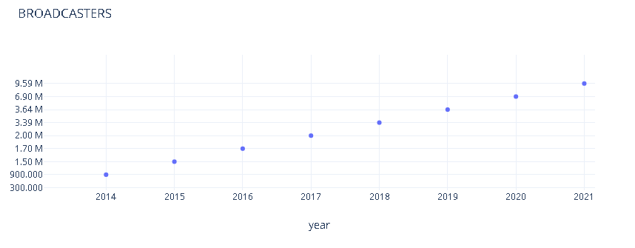

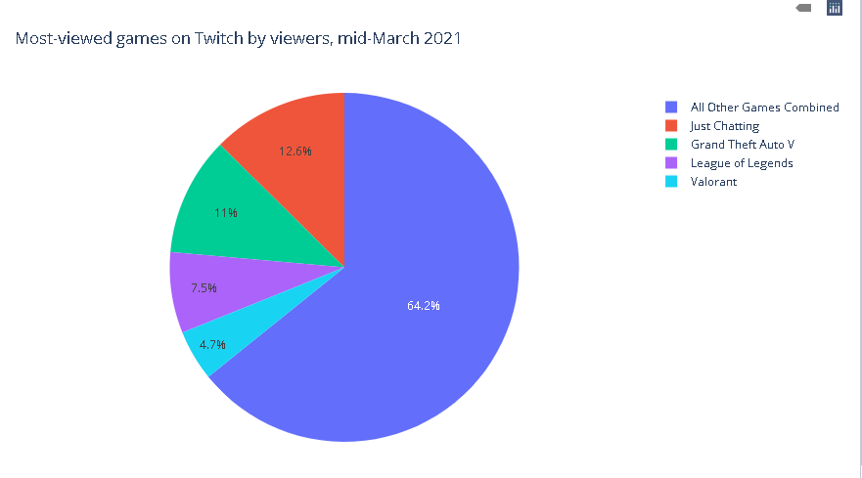

This pie chart shows what people are interested in during this period. Although the games constitute the majority, the amount occupied by the just chatting section actually reveals how much we need to talk during this period.

GeekWire has included the following sentences in an article on this subject: “…The biggest takeaway from the current data is that “Just Chatting” is here to stay. The category — a catch-all term for video logs, reality shows, unscripted programming, and streamers just hanging out with their audience — has grown rapidly over the last year, particularly as pandemic life has forced people all over the world into lockdown conditions. With a full 200 million hours watched on Twitch in October, Just Chatting is far and away the most popular category on the site, outstripping the gameplay-based content that Twitch is more typically known for… “

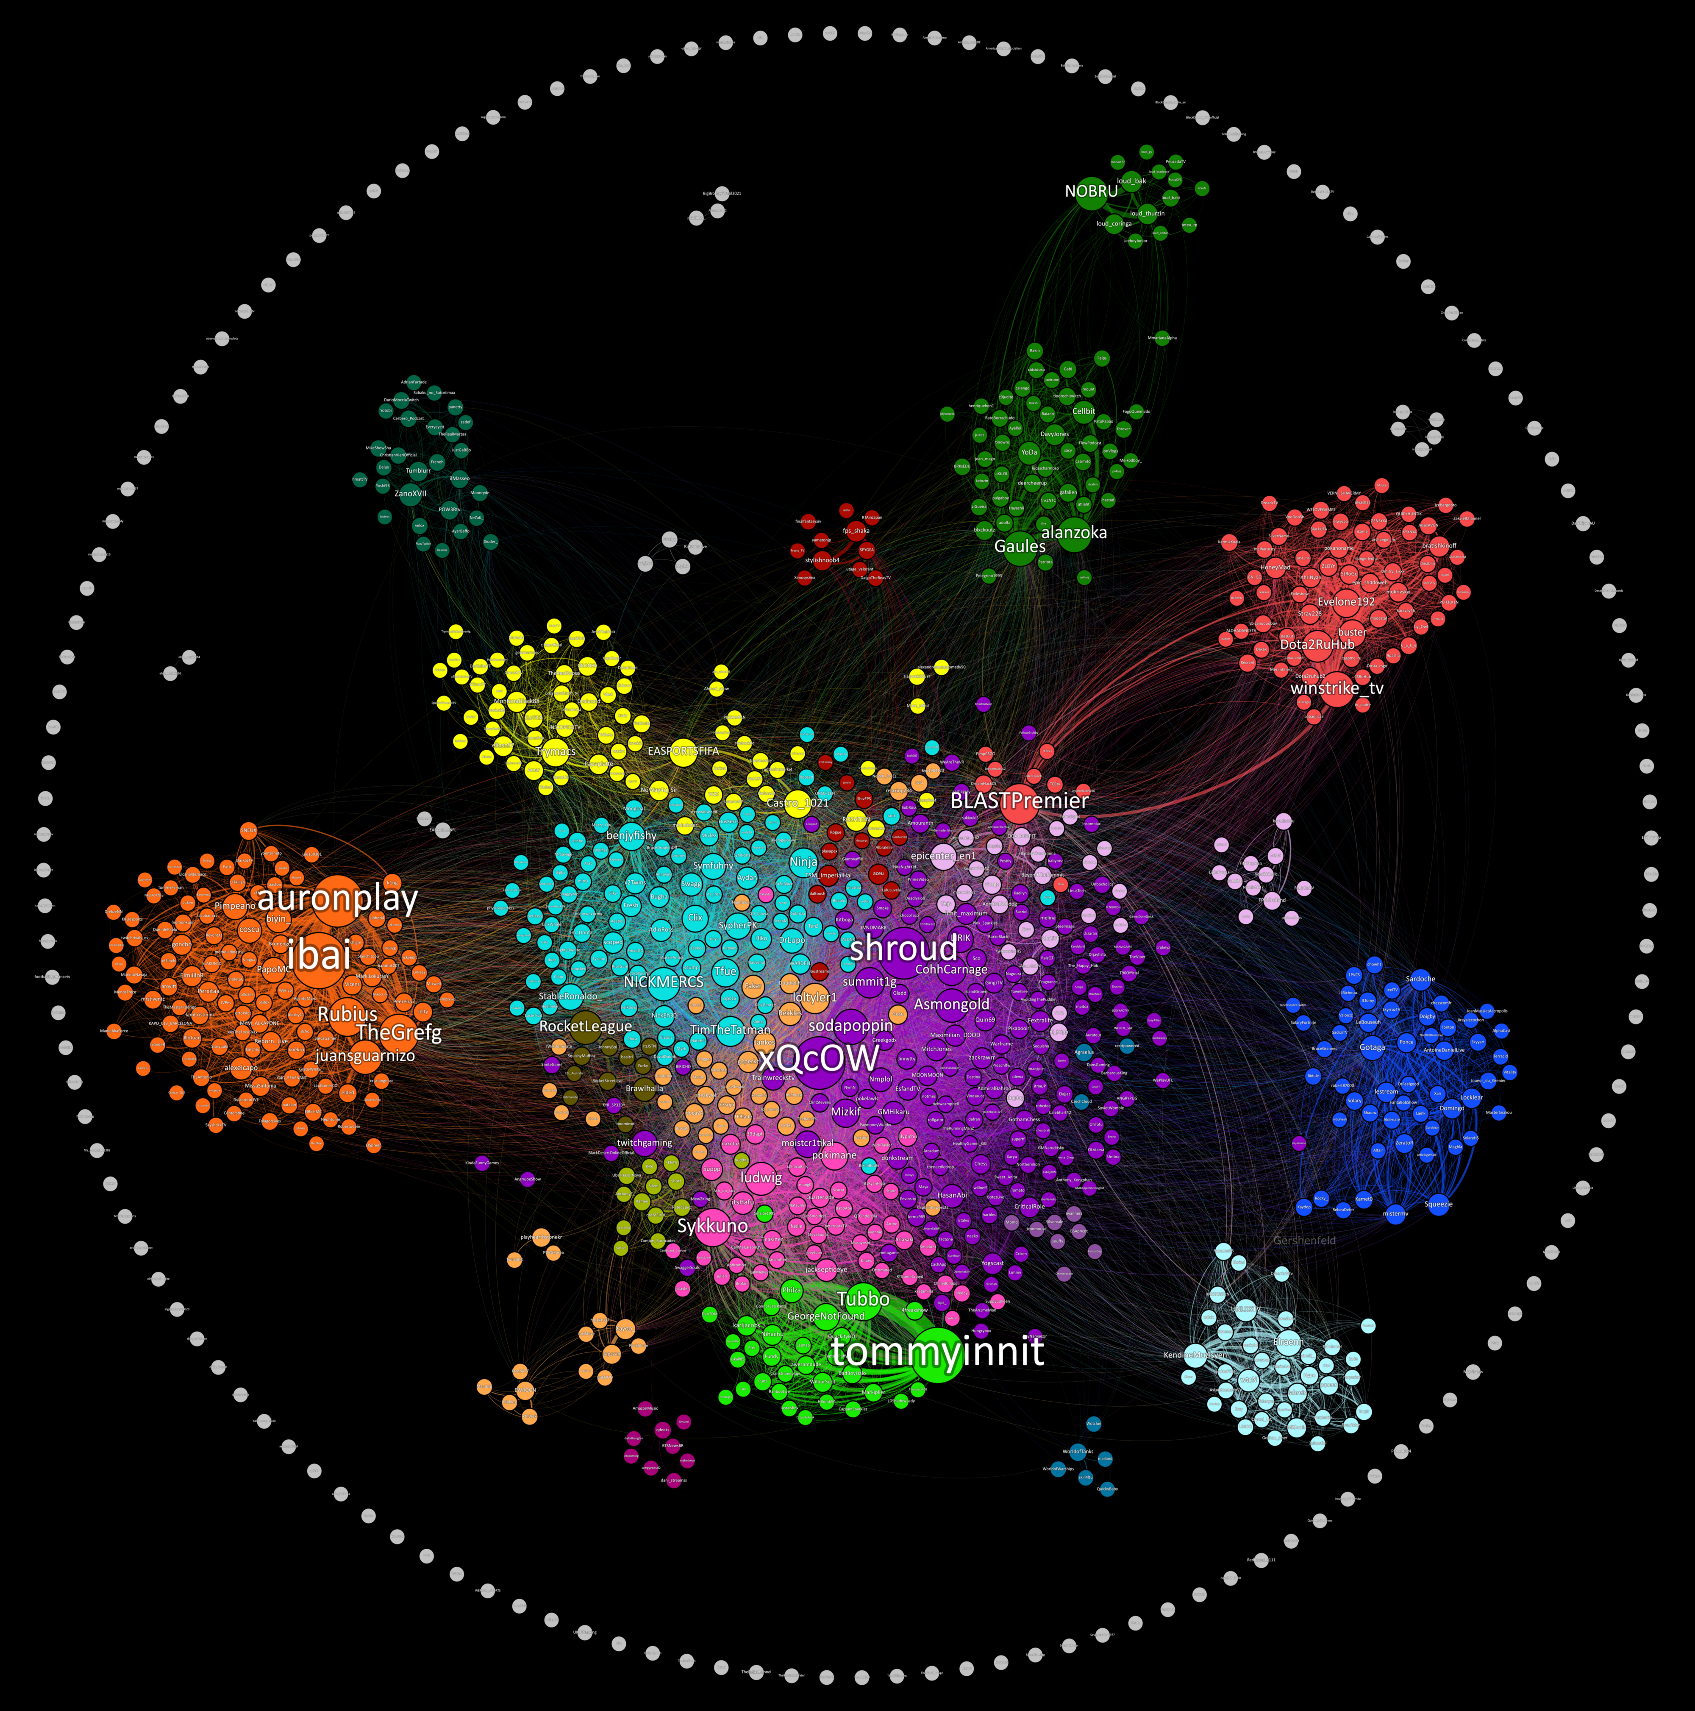

*(Gershenfeld , K. ,Insights from Visualizing Public Data on Twitch,*

*Mapping Communities Using Viewer Trends, Tool : Gephi)*

In this study, I observed the situation using the data of the entertainment site twitch.tv to inform people how our understanding of entertainment has changed. This website has managed to turn the situation in its favor by offering an environment where people can have fun, follow politics closely, attend concerts, and have a good time with their friends. The fact that people are confined to their homes and have limited opportunities has led to this situation. As can be clearly seen in the data images, our understanding of entertainment during the pandemic it has turned to mobile devices and entertainment applications.

REFERENCES:

Kim , S. *, Twıtch: The Ultımate covıd-19 Benefıcıary ,*Mcgıll's student-run news magazine, Jan 25, 2021. Retrieved June 15, 2021, from <http://bullandbearmcgill.com/twitch-the-ultimate-covid-19-beneficiary/>

Clement, J., *COVID-19: Twitch user increase 2020 ,* Jan 29, 2021. Retrieved June 15, 2021, from <https://www.statista.com/statistics/1108340/covid-twitch-users>

https://www.cnnturk.com/teknoloji/twitch-izlenme-sayisini-katladi

<https://chart-studio.plotly.com/create/>

Stephen, B*. ,’’TheVERGE ,This is Twitch’s moment’’ ,* Mar 18, 2020. Retrieved June 15, 2021, from <https://www.theverge.com/2020/3/18/21185114/twitch-youtube-livestreaming-streamelements-coronavirus-quarantine-viewership-numbers>

<https://www.businessofapps.com/data/twitch-statistics/>

<https://www.geekwire.com/2020/twitch-sets-audience-record-october-pandemic-continues-fuel-livestreaming-growth/>

<https://twitchtracker.com/statistics/games>

*Gershenfeld , K. ,Insights from Visualizing Public Data on Twitch, Mapping Communities Using Viewer Trends,*. Retrieved June 15, 2021, from <https://towardsdatascience.com/insights-from-visualizing-public-data-on-twitch-a73304a1b3eb>

<https://www.trackalytics.com/the-most-followed-twitch-channels/page/1/>

https://live.amcharts.com/